MINISTRY OF EDUCATION AND TRAINING
CAN THO UNIVERSITY
COLLEGE OF INFORMATION AND COMMUNICATION TECHNOLOGY



GRADUATION THESIS
BACHELOR OF ENGINEERING IN
INFORMATION TECHNOLOGY
(HIGH-QUALITY PROGRAM)

DEVELOPING A MUSHROOM IDENTIFICATION APPLICATION

Student: Nguyễn Quang Vinh
Student ID: B2105727
Class: 2021-2025 (K47)
Advisor: Dr. Bùi Võ Quốc Bảo

Can Tho, 12/2025
MINISTRY OF EDUCATION AND TRAINING
CAN THO UNIVERSITY
COLLEGE OF INFORMATION AND COMMUNICATION TECHNOLOGY
DEPARTMENT OF INFORMATION TECHNOLOGY

GRADUATION THESIS
BACHELOR OF ENGINEERING IN
INFORMATION TECHNOLOGY
(HIGH-QUALITY PROGRAM)

DEVELOPING A MUSHROOM IDENTIFICATION APPLICATION

Student: Nguyễn Quang Vinh
Student ID: B2105727
Class: 2021-2025 (Cohort K47)
Advisor: Dr. Bùi Võ Quốc Bảo

Can Tho, 12/2025

COMMENTS OF INSTRUCTOR
.......................................................................................................................................
.......................................................................................................................................
.......................................................................................................................................
.......................................................................................................................................
.......................................................................................................................................
.......................................................................................................................................
.......................................................................................................................................
.......................................................................................................................................
.......................................................................................................................................
.......................................................................................................................................
.......................................................................................................................................
.......................................................................................................................................
.......................................................................................................................................
.......................................................................................................................................
.......................................................................................................................................

Can Tho, ………………………. 2025

Advisor

Ph.D. Bui Vo Quoc Bao

ACKNOWLEDGEMENTS
First of all, I would like to express my deep gratitude to Professor Bui Vo Quoc Bao, lecturer at the School of Information and Communication Technology. As an advisor, he has spent a lot of time guiding and supporting me throughout the process of doing the thesis.
I also sincerely thank all the teachers at the School of Information and Communication Technology who have provided me with basic and specialized knowledge throughout the learning process, helping me to complete this thesis.
Finally, I would like to thank my family and friends, those who have always been there to cheer me up and encourage me, helping me overcome the pressures throughout the process of writing this thesis.
Although I have tried my best to complete the topic on time, due to the limitation of time and practical experience, the thesis certainly cannot avoid many shortcomings. I look forward to receiving comments from teachers to help my topic be more complete.

Can Tho, ………………………. 2025
Student

Nguyen Quang Vinh

TABLE OF CONTENTS
COMMENTS OF INSTRUCTOR i
ACKNOWLEDGEMENTS ii
LIST OF FIGURES vi
LIST OF TABLES vii
LIST OF ACRONYMS viii
ABSTRACT ix
CHAPTER 1: INTRODUCTION 1
1. PROBLEM DESCRIPTION 1
2. PURPOSE OF THE STUDY 1
3. THESIS OBJECTIVES AND SCOPE 2
3.1. Research Objectives 2
3.2. Research Scope 2
4. THESIS CONTENT 2
5. RELATED WORKS 4
6. OUTLINE OF THE STUDY 4
CHAPTER 2: THEORETICAL BASIS 5
1. RELATED TECHNOLOGIES AND LIBRARIES 5
1.1. Flutter/Dart 5
1.2. SQLite & JSON 5
1.3. OpenStreetMap 5
1.4. PyTorch 5
1.5. Transformers (HuggingFace) 6
1.6. CUDA 6
1.7. Albumentations 6
1.8. Matplotlib 6
1.9. Lightning AI Studios 6
1.10. FastAPI 7
2. DEEP LEARNING MODEL AND DATASET 7
2.1. DEEP LEARNING 7
2.2. VISION TRANSFORMERS 8
2.3. DATASET PREPARATION 9
2.3.1. Data Collection 9
2.3.2. Dataset 9
2.3.3. Model Hyper-parameters 10
2.4. Model Evaluation metrics 10
CHAPTER 3: SYSTEM DESIGN 12
1. SYSTEM ARCHITECTURE OVERVIEW 12
2. USE CASE DIAGRAM 13
3. MAIN FUNCTION OF THE SYSTEM 14
3.1 Mushroom Identification from Image 14
3.2. Identification History 15
3.3. Mushroom Search 16
3.4. Forage map 17
4. LOCAL DATABASE DESIGN 18
4.1. SQLite table structure 18
4.2. JSON format for mushroom information 19
CHAPTER 4: IMPLEMENTATION 20
1. MOBILE APP UI/UX OVERVIEW 20
1.1. Navigation bar 20
1.2. Mushroom Identifier Screen (Home Screen) 20
1.3. Image Editor Screens 22
1.4. Inference Progress and Result Display 23
1.5. History Screen 24
1.6. History Item Content 25
1.7. Search Screen 26
1.8. Search Result Content 27
1.9. Forage Map Screen 28
1.10. Marker Description 29
2. APP EVALUATION 30
2.1. Testing Objectives 30
2.2. Test Scenario 31
a. Functional Testing 31
b. Non-Functional Testing 32
c. Error Handling and Security Testing 32
d. Testing Environment 33
2.3. Test Results 33
a. Mushroom Identifier Function 33
b. History Function 34
c. Search Function 35
d. Forage Map Function 35
2.4. Model Evaluation results 36
CHAPTER 5: CONCLUSION AND DEVELOPMENT DIRECTION 38
1. CONCLUSION 38
2. DEVELOPMENT DIRECTION 38
REFERENCE 39

LIST OF FIGURES
Figure 1. Average CNN structures [13] 7
Figure 2. Average ViT structures [15] 8
Figure 3. Dataset preparation process 9
Figure 4. System Architecture overview diagram 12
Figure 5. Use case diagram 13
Figure 6. Mushroom Identification feature flowchart 14
Figure 7. Identification History feature flowchart 15
Figure 8. Mushroom Search feature flowchart 16
Figure 9. Forage map feature flowchart 17
Figure 10. Database schema 18
Figure 11. JSON file structure 19
Figure 12. Navigation bar 20
Figure 13. Mushroom identification screen in light mode (left) and dark mode (right) 20
Figure 14. Gallery picker 21
Figure 15. Image Editor Screens 22
Figure 16. Inference in progress (left) and detailed result screen (right) 23
Figure 17. Default History Screen with overflow menu open (left) and History Screen with Sorting option bottom sheet (right) 24
Figure 18. History Item Content Screen 25
Figure 19. Default Search Screen (left) and Search Screen with keyword (right) 26
Figure 20. Search Result Content Screen 27
Figure 21. Default Forage Map Screen (left) and Forage Map Screen with Filter bottom Sheet (right) 28
Figure 22. Marker Description bottom sheet 29
Figure 23. Macro Precision-Recall Curves of ViT (top-left), ResNet-50 (top-right), EfficientNetB4 (bottom-left) and MobileNetV3 (bottom-right) 36
Figure 24. Marco-Averaged ROC Curves of ViT (top-left), ResNet-50 (top-right), EfficientNetB4 (bottom-left) and MobileNetV3 (bottom-right) 37
Figure 25. Marco F1 Score Curves of ViT (top-left), ResNet-50 (top-right), EfficientNetB4 (bottom-left) and MobileNetV3 (bottom-right) 37

LIST OF TABLES
Table 1. Dataset partitioning 10
Table 2. Model Hyper-parameters 10
Table 3. Mushroom 18
Table 4. Functional Test Scenarios 31
Table 5. Non-Functional Test Scenarios 32
Table 6. Error Handling and Security Test Scenarios 32
Table 7. Hardware specifications 33
Table 8. Mushroom Identifier Function test results 33
Table 9. History Function test results 34
Table 10. Search Function test results 35
Table 11. Forage Map Function test results 35
Table 12. Evaluation results 36

LIST OF ACRONYMS
No. | Acronym | Meaning
1 | 1D | One-dimension
2 | 2D | Two-dimension
3 | AI | Artificial Intelligence
4 | API | Application Programming Interface
5 | ARM | Advanced RISC Machine
6 | CLS | Classification Token
7 | CNN | Convolutional Neural Network
8 | CSV | Comma-Separated Values
9 | CUDA | Compute Unified Device Architecture
10 | GIS | Geographic Information System
11 | GPU | Graphics Processing Unit
12 | IDE | Integrated Development Environment
13 | iOS | iPhone Operating System
14 | JAX | Just After Execution
15 | JSON | JavaScript Object Notation
16 | LLM | Large Language Model
17 | MLP | Multilayer Perceptron
18 | NPL | Natural Language Processing
19 | OSM | OpenStreetMap
20 | SQL | Structured Query Language
21 | TPU | Tensor Processing Unit
22 | UI | User Interface
23 | UML | Unified Modeling Language
24 | URL | Uniform Resource Locator
25 | ViT | Vision Transformer

ABSTRACT
The accurate identification of mushroom species is challenging due to visual similarities between edible and toxic varieties, posing significant health risks from misidentification. This thesis presents FungiScan, a beginner friendly Android mobile application designed specifically for beginner foragers and outdoor enthusiasts to identify mushrooms safely and explore related information without requiring prior expertise.
The application uses a server-client model to support the real time image-based mushroom recognition using a Vision Transformer (ViT) model along with several other complementary features. Users can capture or upload a photo, adjust the image size and rotation, then upload it to the server to receive a predicted result with confidence score, detailed descriptions of said species, and a direct link to the trustworthy online resource. All identification results are then saved locally, allowing users to browse their history offline. In addition, a keyword-based search feature powered by a bundled JSON dataset enables users to look up mushroom information by characteristics, habitat, smell, or name. Finally, a forage map feature that integrates the iNaturalist API to display community-submitted observations of mushrooms, and optionally other wild species, on an interactive map around the user’s location, supporting seasonal and radius-based filtering for practical field use.
FungiScan is built using Flutter/Dart for the client and PyTorch-deployed ViT on Lighting.ai server. The app emphasizes simplicity, speed, and accessibility. It aims to serve as a tool that encourages safe foraging practices and self-learning with no login. This thesis demonstrates a practical integration of artificial intelligence with thoughtful mobile design to address real world challenges in mycology identification.

CHAPTER 1: INTRODUCTION

1. PROBLEM DESCRIPTION
The identification of mushroom species has traditionally relied on methods such as field guides, visual comparison, and consultation with experts. While effective in many cases, these approaches often demand a considerable level of prior knowledge about the subject, it can still lead to misclassification, especially for beginners. Many mushroom species display subtle similarities in features such as cap shape, color patterns and gill structure, making cases of misidentification common without experience. With thousands of documented species worldwide and numerous toxic varieties that closely resemble edible ones, misidentification continues to pose risks that range from mild discomfort to severe poisoning or even death.
With the growing interest in outdoor activities [1], hobbyist foraging has increased the demand for accessible tools to assist beginners. Modern smartphones combined with artificial intelligence provide quick and intuitive identification based on photographic input. However, image-based recognition alone is not always sufficient, users might want to look up species by remembered characteristics or verifying what might be fruiting nearby in the current season, or cross reference community observations before deciding to harvest.
This thesis addresses these challenges by developing a comprehensive yet simple mobile solution that combines multiple approaches in a single, accessible application.

2. PURPOSE OF THE STUDY
The purpose of this thesis is to develop FungiScan, beginner friendly system, designed primarily for beginners and hobbyists seeking an approachable way to identify mushrooms.
FungiScan integrates three core functionalities:
- Real-time image-based identification powered by a server-side Vision Transformer (ViT) model, delivering, confidence score, detailed descriptions and a direct link a trustworthy online resource.
- A keyword-searchable database (bundled JSON dataset) that allows users to explore mushroom species by physical characteristics, smell, habitat, toxicity, and other traits even without taking a photo.
- An interactive forage map using the iNaturalist API to display recent, geolocated community observations of forageable and other wild species around the user’s location, with adjustable radius, month, and taxon filters.
Rather than replacing expert knowledge, FungiScan aims to offer initial guidance that helps users become more informed, avoid dangerous specimens, and pursue further learning when needed.

3. THESIS OBJECTIVES AND SCOPE

3.1. Research Objectives
- Develop FungiScan, an Android mobile application that enables safe and reliable mushroom identification for beginners and hobbyists.
- Providing real-time image-based mushroom recognition using a server-side Vision Transformer (ViT) model. Along with an on-device keyword search powered by a bundled JSON dataset and an interactive forage map using the iNaturalist API to display seasonal, geolocated community observations.
- Build a lightweight client-server architecture that delivers fast inference results.
- Create an intuitive, beginner-oriented user interface and overall experience that encourages safe foraging practices and self-learning.

3.2. Research Scope
- Development of the FungiScan Android application using the Flutter framework, targeting devices running Android 13.0 (API 33) and above.
- Implementation and deployment of a Vision Transformer inference model on a cloud server (Lightning.ai), with the server returning only the predicted class index and confidence score. Along with the keyword search feature and the interactive forage map powered by the iNaturalist public API.
- Design and integration of local storage (SQLite) for identification history and a bundled JSON dataset containing comprehensive, searchable mushroom information (descriptions, characteristics, safety tips, online links, etc.).

4. THESIS CONTENT
The thesis is organized around the complete development process of the FungiScan mobile application and the AI model. The main implementation phases include:
- Requirement Analysis:
- Researching and collecting functional requirements for a mobile mushroom identification system and the server infrastructure supporting remote AI inference.
- Researching essential components of image-based species recognition workflows, keyword-based lookup, identification history management, and location-based foraging exploration.
- Researching ViT deep learning architectures, Flutter frameworks, public API, and lightweight client–server communication.
- Design:
- Designing a usecase diagram, system architecture diagram, and flowcharts describing user interactions with the four main features.
- Designing of the local SQLite storage schema and structure of the bundled JSON dataset.
- Designing the architecture of the client-server interaction and integration with external links and API.
- Implementation:
- Developing the Android application using the Flutter framework, including camera/gallery integration, permission handling, local SQLite storage, JSON parsing, network communication and other supporting packages.
- Implementing and deploying of a Vision Transformer (ViT) model using PyTorch, hosted on Lightning.ai.
- Integrating the iNaturalist API for the forage map feature and implementation of the keyword search using the bundled JSON dataset.
- Conducting testing on a real device for both app functionality and API interaction to ensure accurate performance under real world conditions.
- Technology Used:
- Mobile Frontend: Flutter/Dart and supporting packages.
- Backend & AI: Python, PyTorch, FastAPI, LitServe, ViT model.
- Data Storage: SQLite, bundled JSON.
- External APIs: iNaturalist public API, external URLs.
- Deployment: Lightning.ai.
- Design Tools: PowerDesigner, StarUML, PowerPoint.
- Development Tools: Android Studio, Lightning.ai Jupyter Notebook IDE, Kaggle.
- Testing Tools: Physical Android devices.

5. RELATED WORKS
Several mobile applications have been developed for mushroom identification on the Android platform, using machine learning to assist users in fungi recognition. Notable examples include “Picture Mushroom – Mushroom ID” by Next Vision Limited and “Mushroom Identification” by Battery Stats Saver. While these applications demonstrate practical utility in field settings, they often rely on heavy subscription-based models, which may impose a hefty monthly fee or daily identification limits. This can restrict access for casual users, hobbyists, and beginner foragers. Additionally, many existing apps prioritize functionality over simplicity, making the interface less intuitive for beginners.
The FungiScan app addresses these gaps by offering a platform with a simple, user-friendly interface that allows quick mushroom identification, immediate feedback. Along with a keyword-searchable mushroom information that lets users look up species by descriptions and characteristics and an interactive forage map powered by the iNaturalist API showing recent community verified observations around the user’s location. By combining these tools in a single, accessible package, FungiScan significantly lowers the barrier to safe mushroom identification and learning.

6. OUTLINE OF THE STUDY
This thesis is structured as follows: Chapter 1 presents the introduction, including the research problem, study purpose, objectives, scope, and related works. Chapter 2 establishes the theoretical basis. Chapter 3 details the system design. Chapter 4 covers the implementation and testing. Finally, Chapter 5 provides the conclusion and potential future directions.

CHAPTER 2: THEORETICAL BASIS

1. RELATED TECHNOLOGIES AND LIBRARIES

1.1. Flutter/Dart
Flutter is an open-source UI framework, developed by Google released in 2017. It enables cross-platform application development from a single codebase. Without any intermediate bridge context, It can compile directly to native ARM code for both iOS and Android. This performance is achieved through its proprietary rendering engine, Skia, which paints every UI component on the screen. Dart programming language is built into Flutter to provides the language and runtimes that power Flutter apps. Together, this technology stack ensures high performance, a consistent user experience, and accelerated development cycles.

1.2. SQLite & JSON
SQLite is a C-language library that implements a small, fast, self-contained, high-reliability, full-featured, SQL database engine. SQLite is the most used database engine in the world [2]. It is serverless and requires zero configuration, making it an ideal choice for local data storage within mobile applications.
JSON is a lightweight, open standard data interchange format that uses human readable text to represent structured data as name-value pairs and arrays. Widely adopted for its simplicity and language independence, it has become standard for data exchange between web, mobile applications and servers, as well as for local configuration and static data storage in applications.

1.3. OpenStreetMap
OpenStreetMap (OSM) [3] is a collaborative, open-source mapping project that creates and maintains a free, editable global map dataset, encompassing roads, trails, points of interest, and infrastructure, contributed by a worldwide community of volunteers using tools like GPS devices, aerial imagery, and field surveys. Launched in 2004, OSM has grown into a vital resource for GIS professionals, developers, and enthusiasts, powering thousands of downstream projects without proprietary restrictions.

1.4. PyTorch
PyTorch [4] is an open-source deep learning framework known for its flexibility, speed, and Python native design, featuring dynamic computation graphs that enable rapid prototyping and intuitive model development. Widely adopted in both academia and industry, it excels in computer vision, NLP, and generative tasks through a rich ecosystem of libraries, strong GPU acceleration, and seamless support for distributed training and production deployment.

1.5. Transformers (HuggingFace)
A transformers library [5] by Hugging Face provides thousands of pretrained models and unified, user-friendly APIs for fine-tuning and inference across NLP, vision, audio, and multimodal tasks. It offers extensive model hubs, built-in tokenizers, and seamless PyTorch, TensorFlow and JAX interoperability, making it the standard for rapid prototyping and deployment of transformer-based models.

1.6. CUDA
CUDA [6] is NVIDIA’s parallel computing platform and API that enables general purpose computing on GPUs. It dramatically accelerates deep learning workloads, especially matrix operations and convolutions by exploiting the massive parallelism of NVIDIA GPUs, significantly reducing training and inference time compared to CPU only execution.

1.7. Albumentations
Albumentations [7] is a Python library for image augmentations, widely used in computer vision tasks. It offers a collection of augmentation techniques, optimized for efficiency, which are important for effectively increasing the size and diversity of training datasets.

1.8. Matplotlib
Matplotlib [8] is a Python library for creating static, animated, and interactive visualizations. It is often used to generate curves, visualize sample images before and after augmentation, plot confusion matrices, and produce publication quality figures for performance analysis and reporting.

1.9. Lightning AI Studios
Lightning AI Studios [9] is a cloud platform built for AI development and deployment, providing instant GPUs or TPUs, persistent workspaces, and quick production endpoints. Its inference APIs are powered by LitServe [10], a high-performance open source serving engine that delivers auto batching, auto scaling, request streaming, and OpenAPI documentation for PyTorch models with minimal boilerplate on top of FastAPI.

1.10. FastAPI
FastAPI [11] is a modern, high-performance Python web framework for building APIs with automatic OpenAPI documentation and validation using Python type hints. It delivers fast execution thanks to asynchronous support and Starlette/UVicorn underpinnings. It is used under the hood by LitServe to provide type-safe, asynchronous endpoints, validation, and asynchronous request handling.

2. DEEP LEARNING MODEL AND DATASET

2.1. DEEP LEARNING
Deep learning is a subfield of machine learning that draws inspiration from biological neural systems. It uses multiple layers of artificial neural networks to automatically learn meaningful patterns extracted from raw data. With each layer capturing increasingly abstract features of the input. The data flows from the input layer through multiple hidden layers, where nonlinear transformations are applied. Before reaching the output layer to generates the final prediction. The network's depth, often ranging from tens to hundreds of layers or more, enables it to learn complex relationships that simpler models cannot. These models are typically trained on large datasets using gradient-based optimization and backpropagation, allowing the network to iteratively adjust its internal parameters and improve performance.
With increase in GPU computational powers since the early 2010s, the availability of larger datasets, and breakthroughs to solve problems such as vanishing gradients, deep learning achieved a state-of-the-art performance across image classification, natural language processing, speech analysis, and many other tasks, with Convolutional Neural Networks (CNNs) and Vision Transformers (ViTs) becoming two of its most commonly adopted architectures:
Convolutional Neural Networks (CNNs), introduced in the late 1980s with the LeNet architecture [12], are specialized deep neural networks designed primarily for processing grid-like data such as images, medical scans, audio waveforms and more.
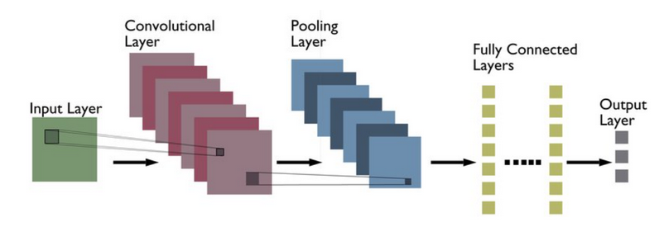
Figure 1. Average CNN structures [13]
Vision Transformers (ViTs), introduced by in 2020 in a paper “An Image is Worth 16×16 Words” [14], adapt the transformer architecture originally developed for natural language processing to vision tasks by dividing images into patches and processing them as sequences, achieving state-of-the-art performance in image classification and related computer vision applications.

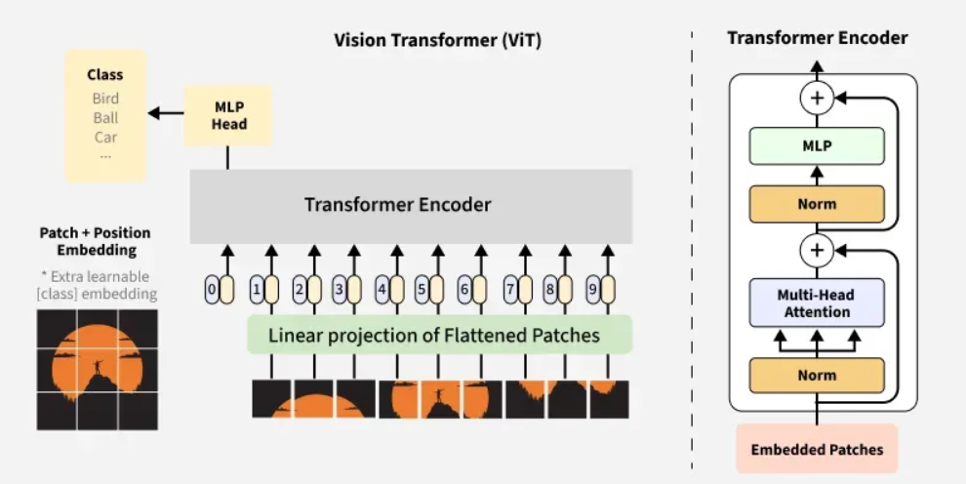
Figure 2. Average ViT structures [15]

2.2. VISION TRANSFORMERS
Vision Transformers (ViT) adapt the transformer architecture, that was originally developed for natural language processing, for image classification. An input image is divided into fixed-size non-overlapping patches, typically 16×16 pixels, each flattened and linearly projected into a vector to form patch embeddings. Positional encodings are added to preserve spatial information, converting the 2D image into a 1D sequence of tokens.
A special (CLS) token is prepended to this sequence. The tokens then pass through multiple transformer encoder layers containing multi-head self-attention and feed-forward networks, stabilized by residual connections and layer normalization. The self-attention mechanism enables every patch to attend to all others simultaneously, capturing long-range dependencies and global context more effectively than traditional convolutional networks.
After the final encoder layer, the (CLS) token’s embedding aggregates information from the entire image and is fed into a small MLP head with softmax activation to produce the class probabilities. This attention-based approach has achieved high performance on many image classification benchmarks when trained on sufficiently large datasets.

2.3. DATASET PREPARATION

2.3.1. Data Collection
No image sample was self-collected during this thesis for the custom dataset. The dataset was entirely assembled from publicly Available sources. The majority were sourced from iNaturalist observations, supplemented by images from the public Kaggle mushroom dataset [16], Wild Food UK [17], and a small number from various small foraging blogs.

2.3.2. Dataset

a. Data preparation
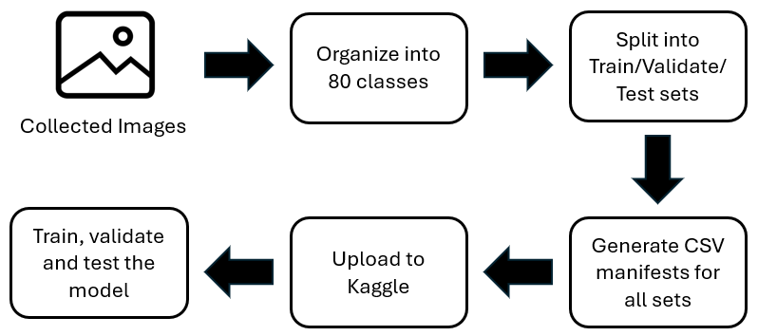
Figure 3. Dataset preparation process

Collected images were first organized into 80 folders representing 80 classes exactly 200 images for each class. A custom Python script was used to randomly split the original dataset into 3 sets of train set, validate set and test set with the ratio of 80-10-10. Another python script is then used to generate three CSV manifest files containing relative file paths and class labels of each image for efficient loading with PyTorch’s DataLoader. The dataset, including the split folders and CSV files, was then uploaded to Kaggle as a private dataset. During training, augmentation is applied to the train set, while validate and test sets only undergo resizing and normalization.

b. Data Augmentation
Augmentation was applied just before training using the Albumentations library to improve model generalization and robustness to real-world field conditions. The train set used HorizontalFlip, VerticalFlip, Rotate, RandomBrightnessContrast, HueSaturationValue, GaussNoise, GaussianBlur, CoarseDropout, and RandomGamma, followed by Resize, Normalize, and ToTensorV2. While the validate and test sets used Resize, Normalize, and ToTensorV2.

c. Set up for ViT Model
Table 1. Dataset partitioning
Set | Percentage | Image per class | Total images | Purpose
Train | 80% | 160 | 12800 | Training the model with data augmentation
Validate | 10% | 20 | 1600 | Tuning hyperparameters and monitoring training
Test | 10% | 20 | 1600 | Final performance evaluation
Total | 100% | 200 | 16000

2.3.3. Model Hyper-parameters
Table 2. Model Hyper-parameters
Variables | Value
Input Size | 224x224
Batch Size | 64
Learning rate | 3e-5 (ViT) and 1e-3 (classifier)
Decay | 1e-4
Epoch | 30
Scheduler | CosineAnnealingLR with T_max=10
Label smoothing | 0.1
Loss function | CrossEntropyLoss
Num classes | 80

2.4. Model Evaluation metrics
True Positive (TP) refers to cases where the model correctly classifies a mushroom image as belonging to class i when that is its actual label, while False Positive (FP) occurs when the model incorrectly assigns an image to class i despite its true label being different. False Negative (FN) represents instances where the model fails to identify an image as class i even though it truly belongs to that class, and True Negative (TN) describes cases where the model correctly identifies that an image does not belong to class i when its actual label is indeed not class i.
Key classification metrics:
- Precision: For a given class, precision measures the proportion of correct positive predictions:
$${\text{Precision}}_{i}=\frac{TP_{i}}{TP_{i}+FP_{i}}$$
- Recall: Also called sensitivity or True Positive Rate, measures the proportion of actual positives that were correctly identified:
$${\text{Recall}}_{i}=\frac{TP_{i}}{TP_{i}+FN_{i}}$$
- F1 Score: Also called harmonic mean of Precision and Recall, particularly useful when dealing with imbalanced classes:
$${\text{F1}}_{i}=2×\frac{{\text{Precision}}_{i}×{\text{Recall}}_{i}}{{\text{Precision}}_{i}+{\text{Recall}}_{i}}$$

- Macro-averaged metrics: All classes are treated equally:
$$\text{Macro-Precision}=\frac{1}{N}\sum_{i=1}^{N}{{\text{Precision}}_{i}},$$
$$\text{Macro-Recall}=\frac{1}{N}\sum_{i=1}^{N}{{\text{Recall}}_{i}},$$
$$\text{Macro-F1}=\frac{1}{N}\sum_{i=1}^{N}{{\text{F1}}_{i}}$$
- Weighted-average metrics: Accounting for class imbalance by weighting each class by its support.
Additional evaluation curves:
The Macro Precision-Recall Curve plots precision against recall at varying confidence thresholds. Macro-Averaged ROC Curve and its AUC measure the relationship between the true positive rate and false positive rate across different thresholds. The Macro F1 Score Curve illustrates how the F1-score changes at various confidence levels, aiding in selecting an operating point that maximizes overall performance.

CHAPTER 3: SYSTEM DESIGN

1. SYSTEM ARCHITECTURE OVERVIEW
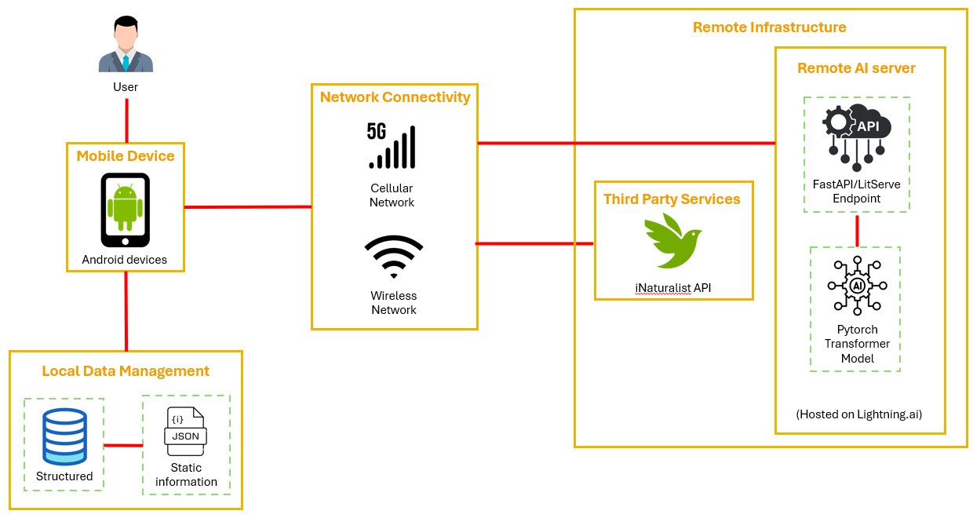
Figure 4. System Architecture overview diagram

The application uses a cloud architecture where the client connects to a remote PyTorch Transformer model through a FastAPI/LitServe endpoint hosted on Lightning.AI, via Wireless network for all real time inference. Locally, an SQLite database stores previously inferred results for instant retrieval and offline access, while a static JSON file serves dual purposes of providing data for inferred results and powering an on-device search feature that allows users to browse data of non-inferred items without persisting them in the database. The forage map feature operates independently by directly querying the public iNaturalist API over the network, retrieving data based on user location, radius, month, and taxon filters, and displaying them on an interactive map.

2. USE CASE DIAGRAM
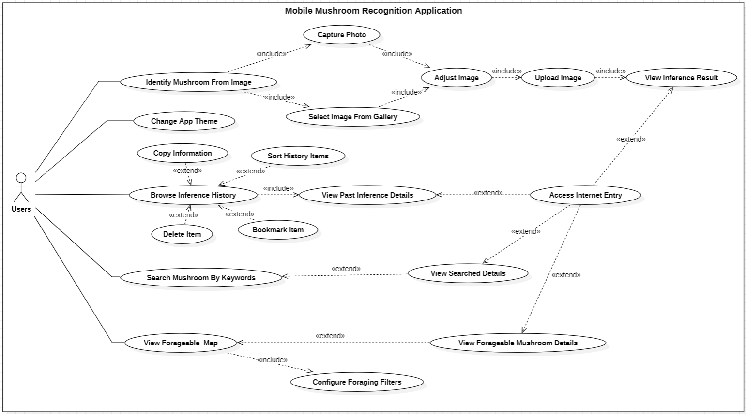
Figure 5. Use case diagram

FungiScan requires no login and consists of these following use cases accessible via a bottom navigation bar:
- Identify Mushroom from Image: capture or select photo, then adjust image (crop, zoom and rotate), then upload image to server for inference and finally view the result with related information and automatically saved to history.
- Change app theme.
- Browse Identification History: view, sort, bookmark, delete or copy content of past inference results and view corresponding Internet entry.
- Search Mushroom by Keyword: text search using the bundled JSON dataset by keywords then view the details.
- View Forageable of various species including mushrooms on an interactive map through iNaturalist API via adjustable filters, then view marker details, upon which user can access the corresponding iNaturalist entry.

3. MAIN FUNCTION OF THE SYSTEM

3.1 Mushroom Identification from Image
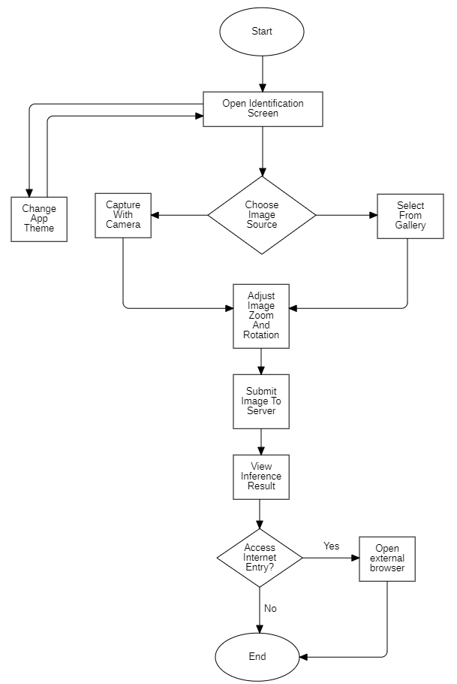
Figure 6. Mushroom Identification feature flowchart

Upon launching FungiScan, the user immediately lands on the Mushroom Identification screen. From here, the user can either change the app theme or choose to capture a new photo via the camera or select an existing image from the gallery. The selected image is then displayed on an adjustment screen where the user can adjust image zoom, crop and rotation to center the mushroom clearly. After confirming with “OK”, the image is sent to the remote server, which runs the Vision Transformer (ViT) model and returns only the predicted class index and confidence score. The app instantly maps this index to the corresponding entry in the bundled JSON dataset, displays the full information of the identify species. Finally, the app automatically saves the complete record to local SQLite history. From the result screen, the user can either return to the identification screen or tap the link icon to open the species article in an external browser.

3.2. Identification History
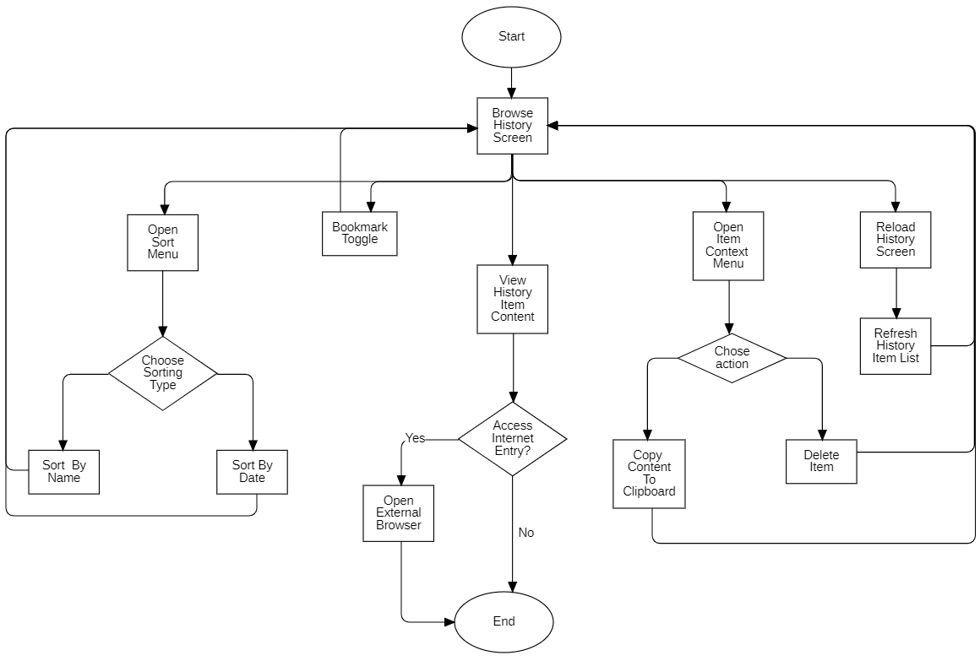
Figure 7. Identification History feature flowchart

Users can switch to the history screen via the bottom bar, this screen all past identification results as a scrollable list of cards and are stored locally in SQLite for full offline access. Users can sort the list by name or date and refresh the list using the action buttons on the top bar. Users can also interact with the history item by bookmarking the item or opening the context menu of said item to copy its content to the clipboard or delete it. Finally, users can view the content of the item by tapping on the item, where they can return to history screen or the corresponding external reference page.

3.3. Mushroom Search
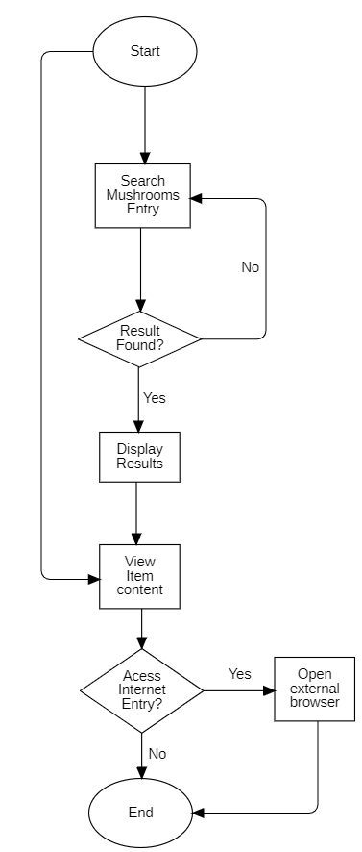
Figure 8. Mushroom Search feature flowchart

The Search screen provides a fast keyword lookup powered by the bundled JSON dataset. Upon switching to the screen via the bottom bar, ten mushroom are immediately displayed as samples to enable quick browsing. If the desired species is among them, the user can tap it directly to view full details. Otherwise, the user enters any keywords, for example: cap color, smell, habitat, scientific or common name) into the search bar; the list instantly filters in real time as characters are typed. Matching results appear as cards, tapping any card opens the complete species Details. If no species matches the query, a friendly “No results found” message is shown. Like all other detail screens, users can optionally open the external reference page.

3.4. Forage map
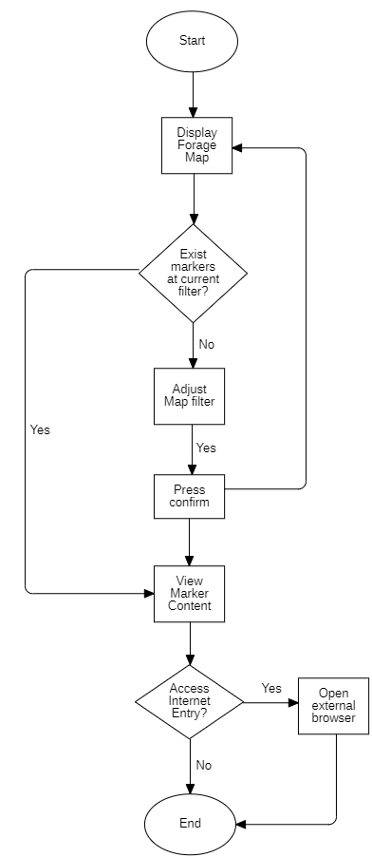
Figure 9. Forage map feature flowchart

The Forage Map screen is an online only feature that displays an interactive map centered on the user’s current location. Upon opening, the map automatically applies the previously used filter settings or defaults filter settings, to show nearby observations sourced from the iNaturalist public API. If observations exist within range, a red markers appear immediately for each observation, tapping any marker opens a bottom sheet with the actual photo, upload date, common/scientific name, and a direct link to the iNaturalist observation entry. When no observations are found, users can modify the radius, month, observation limit and taxon scope (mushrooms only or all organisms) via a filter button on the top bar, triggering a refresh of markers.

4. LOCAL DATABASE DESIGN

4.1. SQLite table structure
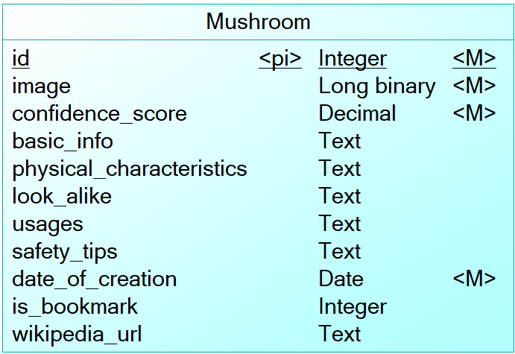
Figure 10. Database schema

FungiScan uses a single SQLite table named mushrooms to store every inference results locally. After a successful inference, the app receives the predicted class key, for example "amethyst_chanterelle", a looks up of the corresponding entry in the mushroom_info.json file, copies all textual information and the cropped image used for inference got inserted into a self-contained record of the database.
Table 3. Mushroom
No | Field name | Data type | Description
1 | id | ObjectID | Entry ID, Primary key, auto-increment
2 | image | Long Binary | Raw image bytes of the cropped/uploaded photo.
3 | confidence_score | Real | Model confidence (0.0 – 1.0)
4 | basic_info | String | JSON string of the entire basic_info object (common name, scientific name, edibility, toxicity level, habitat) from the bundled mushroom_info.json
5 | physical_characteristics | String | Detailed physical traits
6 | look_alike | String | Common look-alikes and warnings
7 | usages | String | Culinary/medicinal uses
8 | safety_tips | String | Toxicity and handling advice
9 | date_of_creation | Date | ISO-8601 timestamp
10 | is_bookmark | Integer | Bookmark flag
11 | wikipedia_url | String | Direct link to the external reference page (could be Wikipedia or other sources)

The mushrooms table serves to store inferred mushroom information and includes fields such as:
- id: This is the primary key of type ObjectID.
- image has data type Long Binary.
- confidence_score has type Real.
- basic_info, physical_characteristics, look_alike, usages, safety_tips and wikipedia_url have data type String.
- date_of_creation has data type Date.
- is_bookmark has data type Integer.

4.2. JSON format for mushroom information
The application contains a static JSON file in the assets folder. It is used as a source of mushroom information and is used for the search feature and to populate inference results.
The JSON is structured as a top-level object whose keys are unique, URL friendly identifiers, for example: "amethyst_chanterelle", "fly_agaric", etc. Each key maps to a comprehensive object containing all required information for that species.

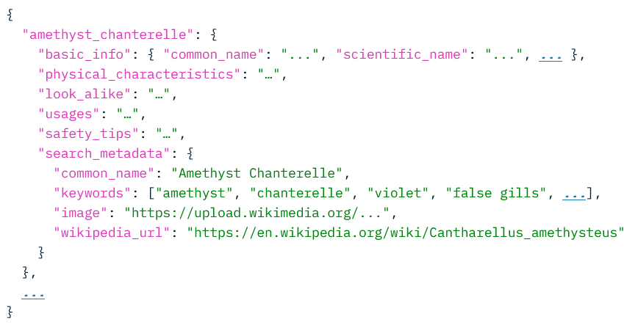
Figure 11. JSON file structure

CHAPTER 4: IMPLEMENTATION

1. MOBILE APP UI/UX OVERVIEW

1.1. Navigation bar

Figure 12. Navigation bar

The application has fixed bottom navigation bar with icons depicting the four main screen of the application, namely, Mushroom Identification (default/home), History, Search, and Forage Map. The navigation bar allows access to all core functions of the app. The currently active tab is highlighted with the primary color to orientate the user.

1.2. Mushroom Identifier Screen (Home Screen)
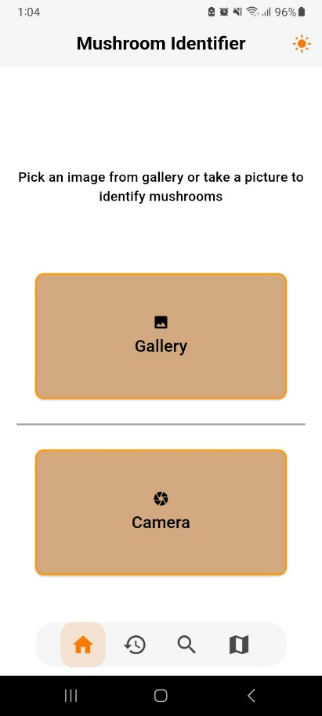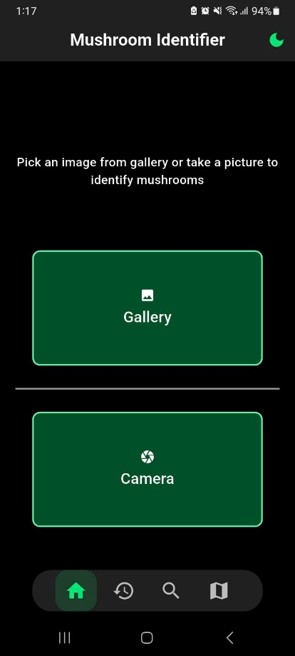
Figure 13. Mushroom identification screen in light mode (left) and dark mode (right)

The Mushroom Identification screen is the default page when users launch the app. A sun/moon icon on the right corner of the app bar allows for switching between light and dark themes. Centered on the screen are two buttons, namely the “From Gallery” button for selecting an existing photo and the “Take Photo” button for opening the device camera. This layout ensures that beginners can start an identification in one tap without any distraction.

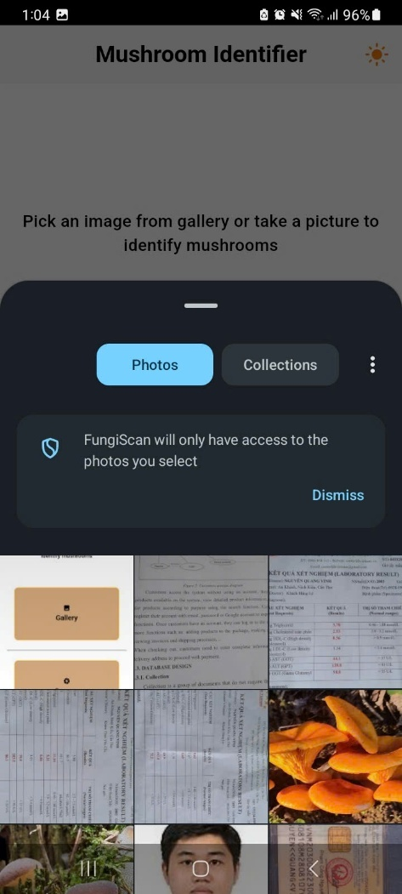
Figure 14. Gallery picker

After tapping on the “From Gallery” button, the gallery picker is presented with a standard system interface for choosing a photo from the device. After selection, the user is directed to the Image Editor screen to crop, rotate, or zoom the mushroom into focus before submission.

1.3. Image Editor Screens
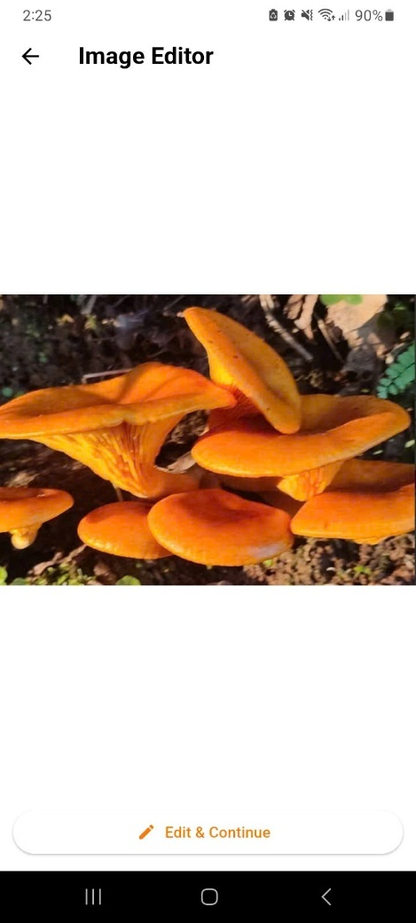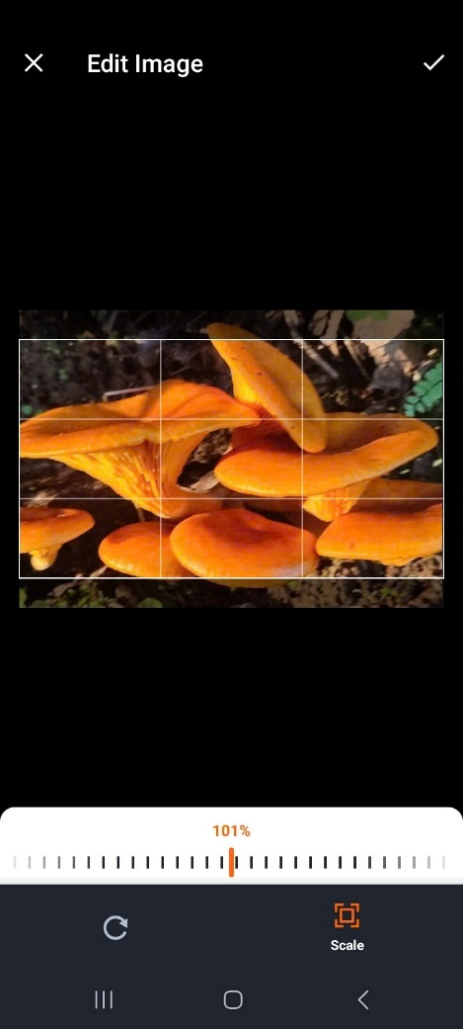
Figure 15. Image Editor Screens

After selecting or capturing a photo, the user is taken to the Image Editor screen. The user is first presented with a preview screen to review the captured/selected photo quickly. After pressing the “Edit & Continue” button the user is then taken to the actual editor screen that displays the photo with the options to crop, zoom, and rotate to ensure the mushroom is centered and clearly visible. Once satisfied, the user taps the checkmark to submit the adjusted image to the remote server for inference.

1.4. Inference Progress and Result Display
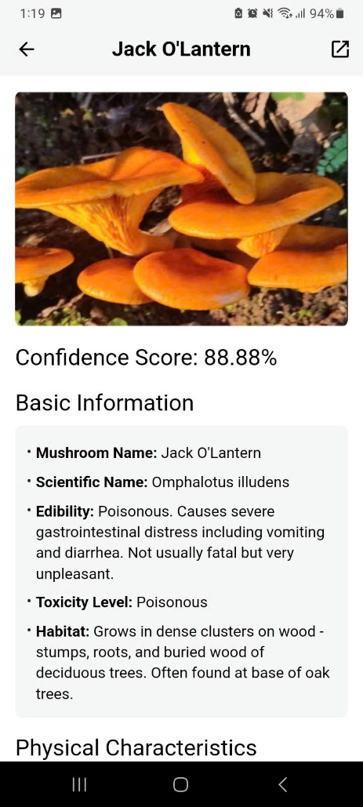
Figure 16. Inference in progress (left) and detailed result screen (right)

The inference process consists of two sequential screens shown side-by-side in figure above:
- Left - Running Inference: A screen displaying only a centered progress indicator and the title “Running inference” while the image is being uploaded and processed by the server.
- Right - Result Screen: Upon receiving the prediction, the app instantly presents the full result where the uploaded photo is at the top, confidence score in large text, followed by sections for Basic Information, Physical Characteristics, Look alike, Usages, and Safety Tips. An external link icon are placed in the app bar for quick access.

1.5. History Screen
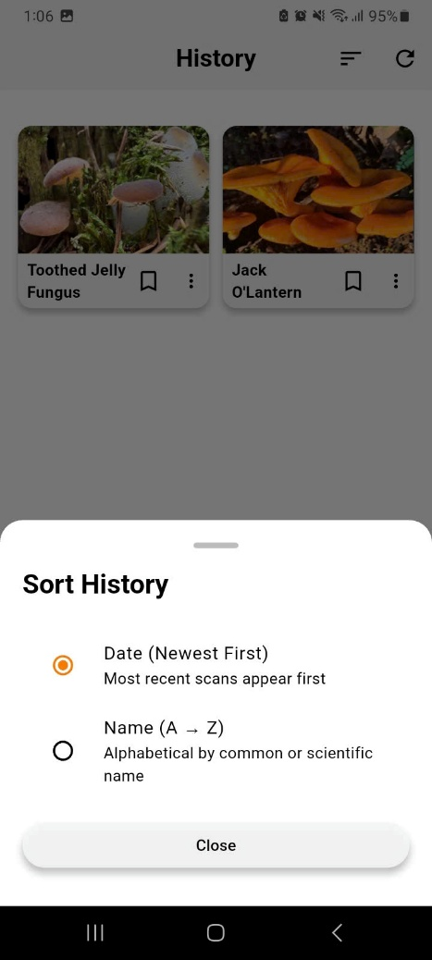
Figure 17. Default History Screen with overflow menu open (left) and History Screen with Sorting option bottom sheet (right)

The History screen displays all previous identifications as a grid of cards, each showing the mushroom thumbnail, common name, bookmark icon, and overflow menu. Two action buttons are placed in the top app bar, namely the sorting button for opening a bottom sheet offering sorting options (date or name), while refresh button reloads the list from local storage. Tapping the overflow menu provides options to copy details of or delete an item card.

1.6. History Item Content
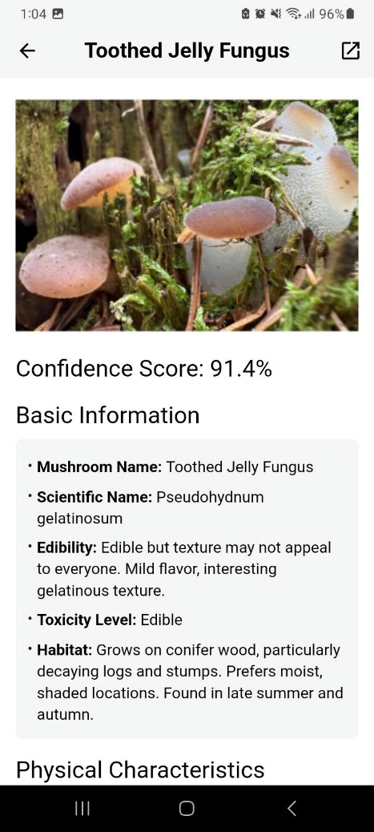
Figure 18. History Item Content Screen

Tapping any card in the History screen opens the full result view, which is identical to the fresh inference result screen. It displays the original photo, confidence score, and the same information sections. An external link icon remain in the app bar, allowing the user to share the result or open the reference page at any time.

1.7. Search Screen
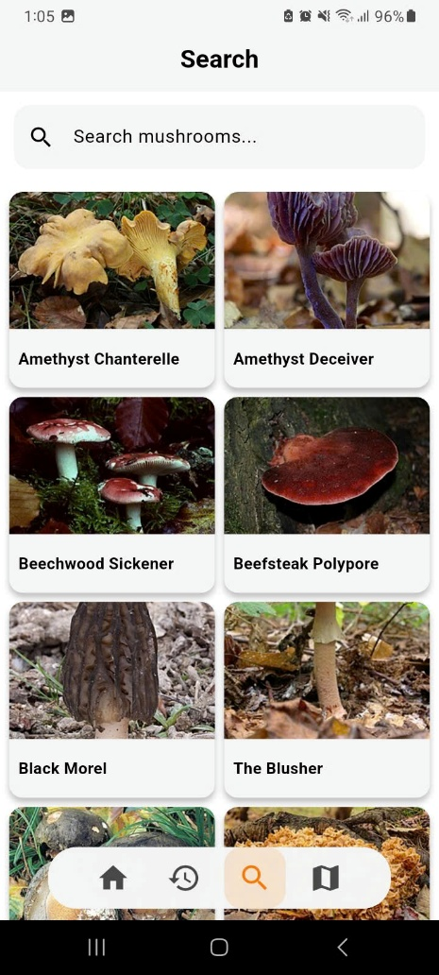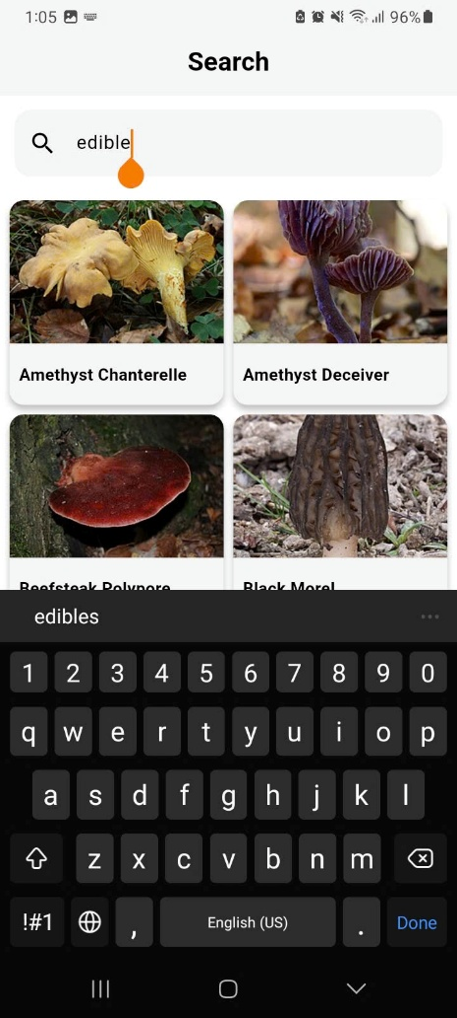
Figure 19. Default Search Screen (left) and Search Screen with keyword (right)

The Search screen offers a real time keyword-based lookup method from the bundled json file. Upon opening, a prominent search bar is displayed at the top with a placeholder “Search mushrooms…”. As the user types, for example: “edible”, results instantly filter and appear as a scrollable grid of cards showing the mushroom photo and common name. When no texts are entered, 10 species are shown by default for quick browsing. Tapping any card opens the same detailed result view used elsewhere in the app.

1.8. Search Result Content
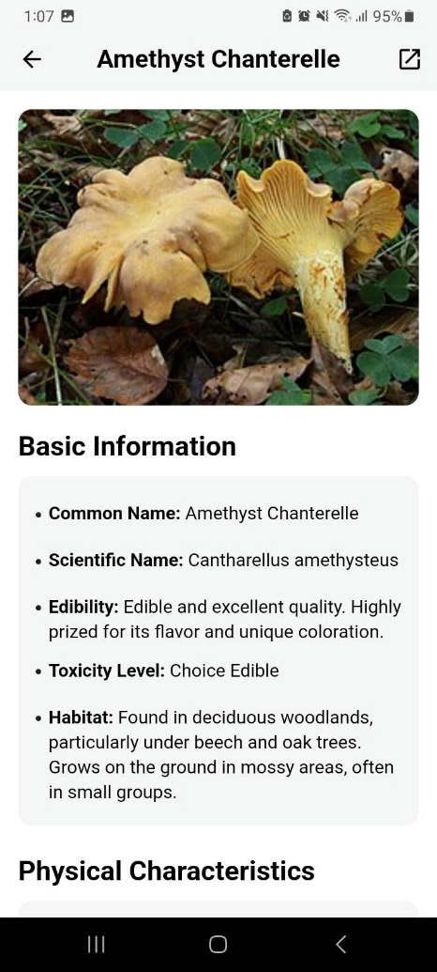
Figure 20. Search Result Content Screen

When a user taps any card in the Search screen, the app opens the detailed result view directly from the bundled JSON dataset. The layout is identical to the inference result screen and history item content screen, but the confidence score is intentionally omitted because no AI inference was performed. A share icon and external link icon remain available in the app bar.

1.9. Forage Map Screen
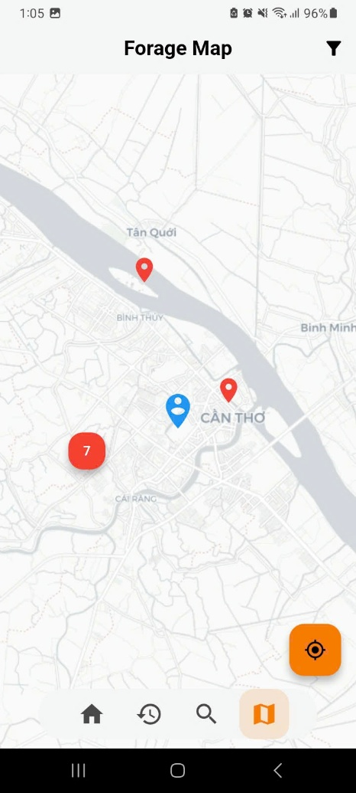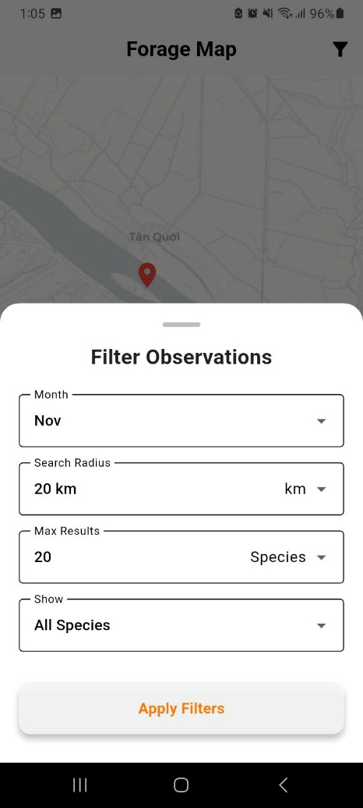
Figure 21. Default Forage Map Screen (left) and Forage Map Screen with Filter bottom Sheet (right)

The Forage Map screen integrates real time iNaturalist observation data with an interactive map to assist users in locating nearby wild forageables and observations. A blue user location pin is centered on the map upon opening, while red markers represent verified iNaturalist observations of either fungi or all other species, depending on the current filter, within the selected radius. An orange floating action button allows instant re-centering on the user’s current position, and a filter icon in the app bar opens the configuration bottom sheet.
The filter bottom sheet provides four adjustable parameters, namely observation month, search radius, maximum number of displayed results, and a toggle between “Mushroom only” and “All species.” Changes are applied instantly upon tapping the “Apply Filters” button. This then updates the visible red markers after a full page reload. This feature enables foragers to discover seasonal hot spots to plan forage trips or just learn about the wildlife and their surroundings.

1.10. Marker Description
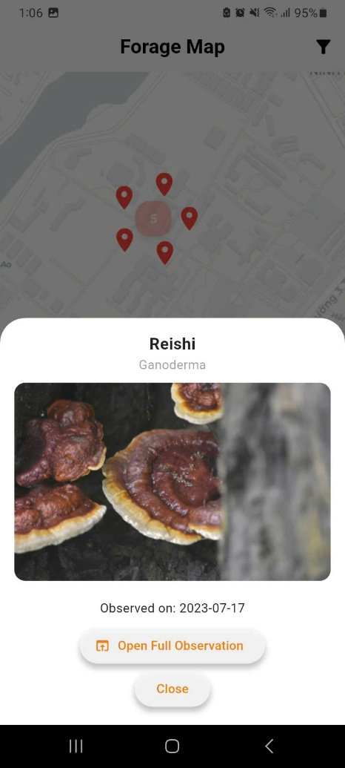
Figure 22. Marker Description bottom sheet

Tapping any red marker on the Forage Map opens a bottom sheet displaying the observed species’ common name, scientific name, a community summited photo, the observation date and a “Open Full Observation” button to redirect user to the iNaturalist entry of said observation on the device’s browser, which can further provide access to additional photos, community identifications, and precise coordinates.

2. APP EVALUATION

2.1. Testing Objectives
The testing phase of the FungiScan application is to ensure that the product meets the functional, performance, usability, and reliability requirements defined in previous chapters:
- Validate Functional Requirements: Confirm that all core features operate exactly as specified:
  - Accurate image capture/upload, adjustment, server inference, and result display.
  - Correct functionality of the keyword search and identification history.
  - Correct integration and interaction with the iNaturalist public API.
  - Accurate retrieval and persistence of identification history and bookmarks.
  - Instantaneous and persistent theme switching
- Validate Non-Functional Requirements: Assess performance and responsiveness on real devices:
  - Inference response time must remain acceptable, under 8 seconds on average under typical 4G/Wi-Fi conditions.
  - App launch time, screen navigation, and list scrolling must feel instantaneous.
- Validate Offline Capabilities: Guarantee full functionality of offline features:
  - Browsing the bundled dataset.
  - Viewing complete identification history with images and information.
  - Proper restoration of bookmarks and sort preferences.
- Evaluate Usability and User Experience: Confirm that the interface is intuitive and beginner friendly:
  - First time users must be able to perform a complete identification workflow in under 30 seconds without guidance.
  - All interactive elements must be easily discoverable and provide appropriate feedback.
  - Error messages and empty states must be clear and helpful.
- Assess Security and Privacy: Ensure the application is secured and private:
  - No unnecessary permissions are requested.
  - All external links open in the system browser with appropriate intent flags.

2.2. Test Scenario

a. Functional Testing
Table 4. Functional Test Scenarios
No. | Test Scenario | Expected Result | Date Tested
1 | Launch application | App opens directly to Mushroom Identification screen, no login required | 20/11/2025
2 | Take photos using camera | Camera opens, photo is captured and redirected to Image Editor screen | 20/11/2025
3 | Select photo from gallery | System gallery picker opens, selected image and redirected to Image Editor screen | 20/11/2025
4 | Crop, rotate, and zoom image in adjustment screen | Image is correctly adjusted and “OK” button sends it to server | 20/11/2025
5 | Successful inference | Progress screen to result screen with photo, confidence score, and full details | 20/11/2025
6 | Automatic saving to history after inference | Results appear immediately in History tab with and thumbnail | 20/11/2025
7 | View identification history | All previous results displayed correctly with images and information | 20/11/2025
8 | Bookmark and unbookmark history item | Bookmark icon toggles, state persists after app restart | 20/11/2025
9 | Delete history item | Item removed permanently | 20/11/2025
10 | Sort history by date and by name | List correctly reordered after selecting sort option | 20/11/2025
11 | Keyword search | Real-time filtering works instantly, default 10 items shown when empty | 20/11/2025
12 | Open species detail from search result | Full detail screen, without confidence score, displayed correctly | 20/11/2025
13 | Forage Map loads observations | Map centered on current location, red markers appear for nearby observations | 20/11/2025
14 | Apply radius, month, and taxon filters | Markers refresh correctly according to selected filters | 20/11/2025
15 | Tap marker to view observation bottom sheet | Photo, name, date, and “Open Full Observation” button work correctly | 20/11/2025
16 | Open external sources links | System browser opens with correct URL | 20/11/2025
17 | Switch between light and dark theme | Theme changes instantly and persists across screens and restarts | 20/11/2025

b. Non-Functional Testing
Table 5. Non-Functional Test Scenarios
No. | Test Scenario | Expected Result | Date Tested
1 | First identification in under 30 seconds | From launch to result displayed in under 30 seconds | 20/11/2025
2 | Average inference time on 4G/Wi-Fi | Total time under 8 seconds | 20/11/2025
3 | App launch time | Cold starts under 8 seconds | 20/11/2025
4 | Scrolling performance in History and Search | Smooth scrolling. | 20/11/2025

c. Error Handling and Security Testing
Table 6. Error Handling and Security Test Scenarios
No. | Test Scenario | Expected Result | Date Tested
1 | Inference with no internet connection | Clear message “No internet connection” and option to retry | 20/11/2025
2 | Search screen with no internet | Can still access the mushroom information but thumbnail image display default error image | 20/11/2025
3 | Forage Map with no internet | Shows clear error message with retry option | 20/11/2025
4 | Server temporarily unreachable | Display error message, retry option | 20/11/2025
5 | Deny camera and gallery permission | Shows error message dialogue with options to either cancel or open system settings. | 20/11/2025
6 | Deny location permission | Returns to forage map screen and shows “Cannot find user location” message | 20/11/2025
7 | Force close app during inference | On reopen, user returns to identification screen safely | 20/11/2025
8 | Verify no unnecessary permissions | Only Camera, Storage (optional), and Location (optional) requested | 20/11/2025

d. Testing Environment
All tests were performed exclusively on a real physical Android device to ensure the results reflect actual field usage conditions by the targeted users. No emulators were used.
- Device used: Samsung Galaxy A12
- Android version: Android 13 (API level 33)
- Hardware specifications:
Table 7. Hardware specifications
Component | Specification
Processor | MediaTek MT6765 Helio P35 (12 nm) octa-core
CPU | Exynos 850
GPU | Mali-G52
RAM | 6 GB
Internal storage | 128 GB
Display | 6.5 inches LCD, 720 × 1600 pixels
Rear camera | 12 MP (wide) + 5 MP (ultrawide)
Battery | 5 000 mAh
Network tested | Wi-Fi and 4G

2.3. Test Results

a. Mushroom Identifier Function
Table 8. Mushroom Identifier Function test results
No. | Test Scenario | Expected Result | Date Tested | Result
1 | Launch application | Opens directly to Mushroom Identification screen, no login | 20/11/2025 | Pass
2 | Take photos using camera | Camera opens, picture taken and transfer to Image Editor screen | 20/11/2025 | Pass
3 | Select photo from gallery | Gallery picker opens, picture chosen and transfer Image Editor screen | 20/11/2025 | Pass
4 | Crop, rotate, and zoom image | Adjustments applied correctly | 20/11/2025 | Pass
5 | Successful inference | Progress screen to full result with confidence score and details | 20/11/2025 | Pass
6 | Open external link | Opens correct URL in system browser | 20/11/2025 | Pass
7 | Automatic saving to history after inference | Result instantly appears in History tab | 20/11/2025 | Pass
8 | Switch between light and dark theme | Theme changes instantly and persists | 20/11/2025 | Pass
9 | Average inference time | Under 8 seconds | 20/11/2025 | Pass
10 | Inference with no internet | Clear error message with return option | 20/11/2025 | Pass
11 | Server temporarily unreachable | Clear error message with return option | 20/11/2025 | Pass
12 | Deny camera permission | Returns to home screen | 20/11/2025 | Pass
13 | Force close app during inference | Returns safely to identification screen | 20/11/2025 | Pass

b. History Function
Table 9. History Function test results
No. | Test Scenario | Expected Result | Date Tested | Result
1 | View identification history | All previous results displayed with thumbnails and full information | 20/11/2025 | Pass
2 | Bookmark and unbookmark history item | Bookmark states toggles and persists after restart | 20/11/2025 | Pass
3 | Delete history item | Item permanently removed | 20/11/2025 | Pass
4 | Sort history by date and by name | List correctly reordered | 20/11/2025 | Pass
5 | Open external link | Opens correct URL in system browser | 20/11/2025 | Pass
6 | Scrolling performance in History | Smooth scrolling | 20/11/2025 | Pass

c. Search Function
Table 10. Search Function test results
No. | Test Scenario | Expected Result | Date Tested | Result
1 | Keyword search | Real-time filtering, default 10 items when search bar empty | 20/11/2025 | Pass
2 | Open species detail from search result | Full detail screen displayed with no confidence score | 20/11/2025 | Pass
3 | Open external link | Opens correct URL in system browser | 20/11/2025 | Pass
4 | Scrolling performance in | Smooth scrolling | 20/11/2025 | Pass

d. Forage Map Function
Table 11. Forage Map Function test results
No. | Test Scenario | Expected Result | Date Tested | Result
1 | Load observations | Map centered on user location, red markers appear | 20/11/2025 | Pass
2 | Apply radius, month, taxon filters | Markers refresh correctly according to selected filters | 20/11/2025 | Pass
3 | Tap marker to view observation bottom sheet | Shows photo, name, date, and “Open Full Observation” button | 20/11/2025 | Pass
4 | Open iNaturalist link from marker | Opens correct observation entry in browser | 20/11/2025 | Pass
5 | Forage Map with no internet | Clear error message with retry option | 20/11/2025 | Pass
6 | Deny location permission | Returns to forage map screen and show error message | 20/11/2025 | Pass

2.4. Model Evaluation results
Table 12. Evaluation results
Model | Precision | Recall | F1 Score | AUC
ViT | 0.89 | 0.88 | 0.88 | 0.998
ResNet-50 | 0.85 | 0.84 | 0.84 | 0.997
EfficientNetB4 | 0.84 | 0.83 | 0.83 | 0.996
MobileNetV3 | 0.83 | 0.82 | 0.82 | 0.995

The ViT model outperforms all three CNN-based models across precision, recall, F1 score, and AUC, indicating stronger overall classification performance on the mushroom dataset.

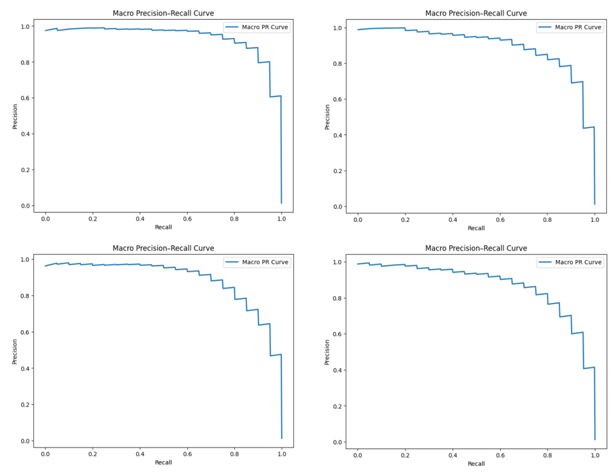
Figure 23. Macro Precision-Recall Curves of ViT (top-left), ResNet-50 (top-right), EfficientNetB4 (bottom-left) and MobileNetV3 (bottom-right)

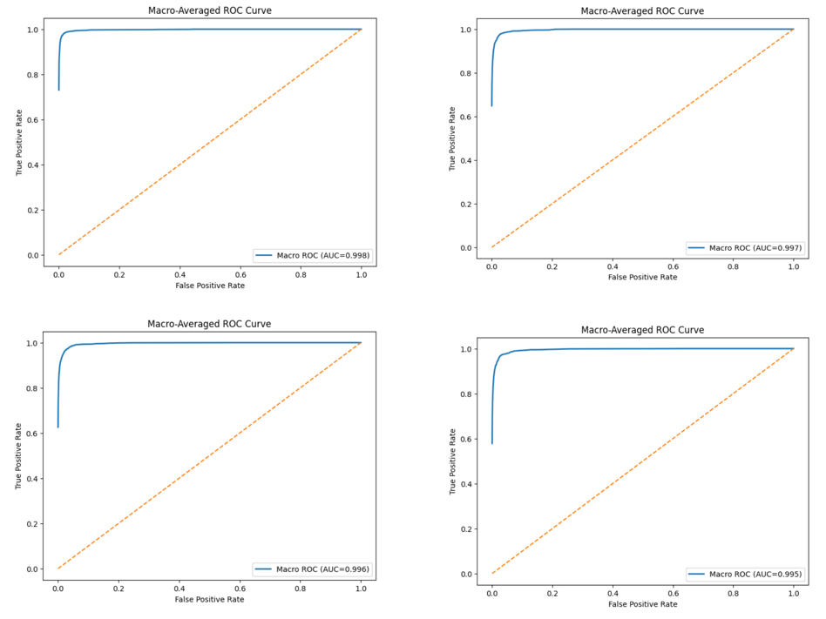
Figure 24. Marco-Averaged ROC Curves of ViT (top-left), ResNet-50 (top-right), EfficientNetB4 (bottom-left) and MobileNetV3 (bottom-right)

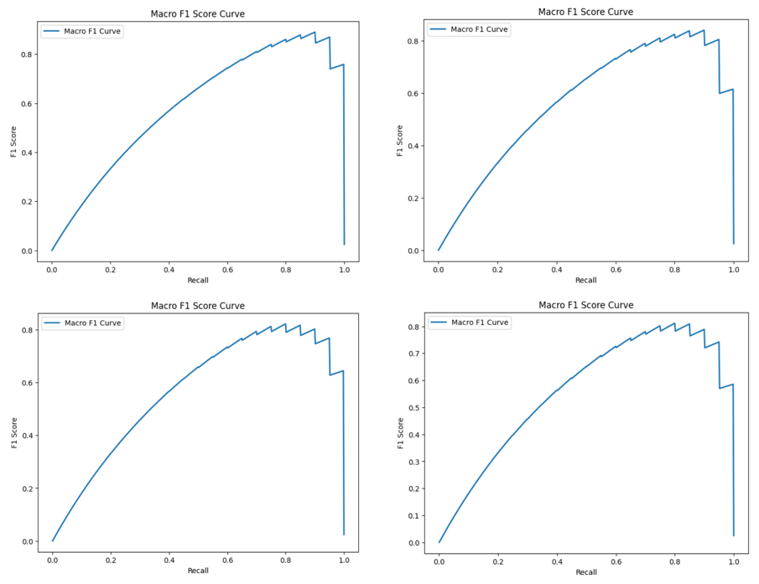
Figure 25. Marco F1 Score Curves of ViT (top-left), ResNet-50 (top-right), EfficientNetB4 (bottom-left) and MobileNetV3 (bottom-right)

CHAPTER 5: CONCLUSION AND DEVELOPMENT DIRECTION

1. CONCLUSION
This thesis successfully developed FungiScan a beginner friendly Android mobile application that serves as a tool for safe mushroom identification. By integrating complementary features, the application effectively addresses the real-world challenges faced by novice foragers:
- Real-time image-based identification powered by a server-side Vision Transformer (ViT) model, with results locally stored after each inference.
- A keyword-based search feature based on a bundled JSON dataset.
- An interactive forage map using INaturalist API to display local, geolocated community observations with adjustable filters.
The project demonstrates a practical integration of artificial intelligence, mobile development, cloud-based inference, and public APIs, contributing a valuable educational and safety tool to the mycology and foraging community.

2. DEVELOPMENT DIRECTION
Due to time and computational resources constraints, I could not implement a large-scale data collection, extended model training, and additional feature development and refinement of current features for the mobile application. Nevertheless, the current system provides a solid and scalable foundation. Thus, I propose some future development directions:
- Expand the recognition scope beyond mushrooms to include other wild edibles (berries, herbs, roots, etc.) and common toxic plants, either through multi-task models or separate specialized classifiers.
- Either implement a larger ViT variants models to achieve a more reliable performance or implement full offline inference using a ViT to eliminate dependency on internet connectivity.
- Collect a larger and higher-quality as well as refine data augmentation strategies to further mitigate overfitting dataset to further improve model accuracy.
- Upgrade the current keyword-based search feature into a chatbot interface powered by a small LLM that understands natural language queries.
- Add user contributed observation to INaturalist feature to enrich the forage map with local data.

REFERENCE
- M. Rombach and D. L. Dean, “Exploring Key Factors Driving Urban Foraging Behavior in Garden and Non-Garden Locations,” Foods, vol. 12, no. 5, p. 1032, Feb. 2023. [Online]. Available: https://doi.org/10.3390/foods12051032
- SQLite Consortium, 2025. [Online]. Available: https://sqlite.org/index.html
- OpenStreetMap Foundation, "About OpenStreetMap," Nov. 2025. [Online]. Available: https://www.openstreetmap.org/about.
- PyTorch Foundation, "PyTorch," Nov. 2025. [Online]. Available: https://pytorch.org/projects/pytorch/.
- Hugging Face, “Transformers Documentation,” Nov. 2025. [Online]. Available: https://huggingface.co/docs/transformers/index.
- NVIDIA, “CUDA Toolkit Documentation,” Nov. 2025. [Online]. Available: https://docs.nvidia.com/cuda/.
- A. Buslaev, V. Iglovikov, E. Khvedchenya, A. Parinov, M. Druzhinin, and A. Kalinin, "Albumentations: Fast and Flexible Image Augmentations," Information, vol. 11, no. 2, p. 125, Feb. 2020. [Online]. Available: https://pypi.org/project/albumentations/
- Matplotlib Development Team, "Matplotlib — Visualization with Python," Nov. 2025, [Online]. Available: https://matplotlib.org/.
- Lightning AI, “Lightning AI Getting Started,” Nov. 2025. [Online]. Available: https://lightning.ai/docs/overview/getting-started
- Lightning AI, “LitServe Home,” Nov. 2025. [Online]. Available: https://lightning.ai/docs/litserve/home
- T. Ramírez, “FastAPI — Documentation,” Nov. 2025. [Online]. Available: https://fastapi.tiangolo.com/.
- Y. LeCun, L. Bottou, Y. Bengio, and P. Haffner, “Gradient-based learning applied to document recognition,” Proc. IEEE, vol. 86, no. 11, pp. 2278–2324, Nov. 1998. [Online]. Available: https://ieeexplore.ieee.org/document/726791
- A Kumar, “Different Types of CNN Architectures Explained: Examples”, Nov. 4, 2023. [Online]. Available: https://vitalflux.com/different-types-of-cnn-architectures-explained-examples/
- A. Dosovitskiy et al., "An Image is Worth 16x16 Words: Transformers for Image Recognition at Scale,", Oct. 22, 2020. [Online]. Available: https://arxiv.org/abs/2010.11929
- GeeksForGeeks, "Vision Transformer (ViT) Architecture”, Jul. 23, 2025. [Online]. Available: https://www.geeksforgeeks.org/deep-learning/vision-transformer-vit-architecture/
- D. Onishchenko. (2023) Mushrooms images classification 215 [Dataset]. Kaggle. Sep. 2025. [Online]. Available: https://www.kaggle.com/datasets/daniilonishchenko/mushrooms-images-classification-215.
- Wild Food UK, Wild Food UK - Foraging trips and courses, UK. Sep. 2025. [Online]. Available: https://www.wildfooduk.com/.

